| Hokey Pokey |

Ingredients: (Makes 125g)
100g castor sugar
4 x 15ml tablespoons golden syrup
1 1/2 tsp bicarbonate of soda
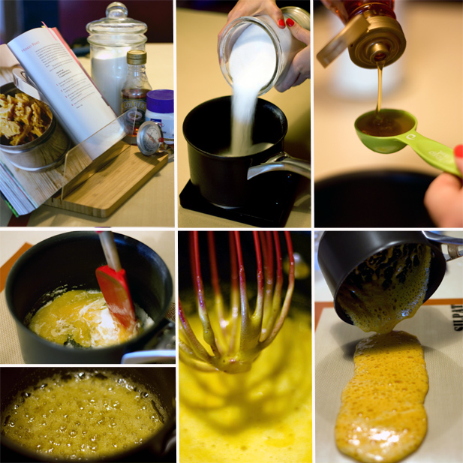

Put the sugar and syrup into a saucepan and stir together to mix. Don’t stir once the pan’s on the heat though – swirl the pan if you see the edges getting brown before the rest of the mixture.

Place the pan on the heat and let the mixture first melt, then turn to goo and then to a bubbling mass the colour of maple syrup – this will take 3 minutes or so.

The boiling sugar should turn a deep amber colour when it reaches the correct stage. Too pale and the candy will not set, too dark and the sugar will have burnt. Ideally, you should use a sugar thermometer – they are super handy and mean you won’t burn or undo the caramel, both of which will mean you need to start all over again.

Aim for hard crack stage which is 150-154C. Off the heat, whisk in the bicarbonate of soda and watch the syrup turn into a whooshing cloud of aerated pale gold. At this stage, leave it to bubble up and do not be tempted to touch or stir it.

Turn this immediately onto a piece of reusable baking parchment or greased foil [I used a Silpat mat - trust me, this thing will be your new best friend in the kitchen].

Leave until set and then bash at it, so that it splinters into many glinting pieces.

* Recipe submitted by Jules Durrant on Spatula.co.za.

